Calibration of time unit for SNF 1M8 beta=4, Km=0.1, At=0.3

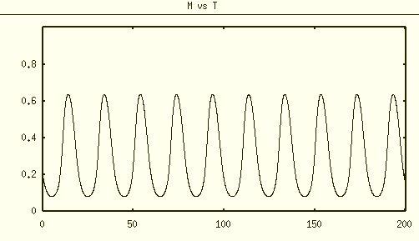

SNF 1M8 FCRTR=FCATR=1

period $\hat{T}≈$ 20

To make the period of default SNF 1M8 to be ~24h, $t=\frac{1}{β_{1}}\hat{t}$, therefore $β_{1}=$ 5/6

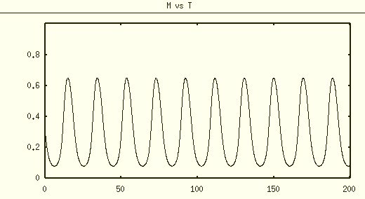

NNF 1M8 FCRTR=FCATR=1

period $\hat{T}≈$ 20

To make the period of default SNF 1M8 to be ~24h, $t=\frac{1}{β_{1}}\hat{t}$, therefore $β_{1}=$ 5/6

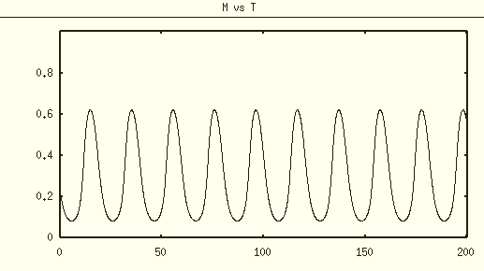

PNF 1M8 FCRTR=FCATR=1

period $\hat{T}≈$ 20

To make the period of default SNF 1M8 to be ~24h, $t=\frac{1}{β_{1}}\hat{t}$, therefore $β_{1}=$ 5/6